SQL> Create Table TrazaTransa (

ID_Transaccion varchar2 (2) Primary Key,

Tabla varchar (30),

IDCliente varchar (4),

Tip_Ahorro Varchar (50),

Tip_Transacion Varchar (50),

Saldo_Anterior number,

MontoDep_Retiro number,

SaldoFinal Number,

Usuario Varchar2 (20),

Fecha Date,

Foreign Key (IDCliente) References Ahorros (IDCliente)

);

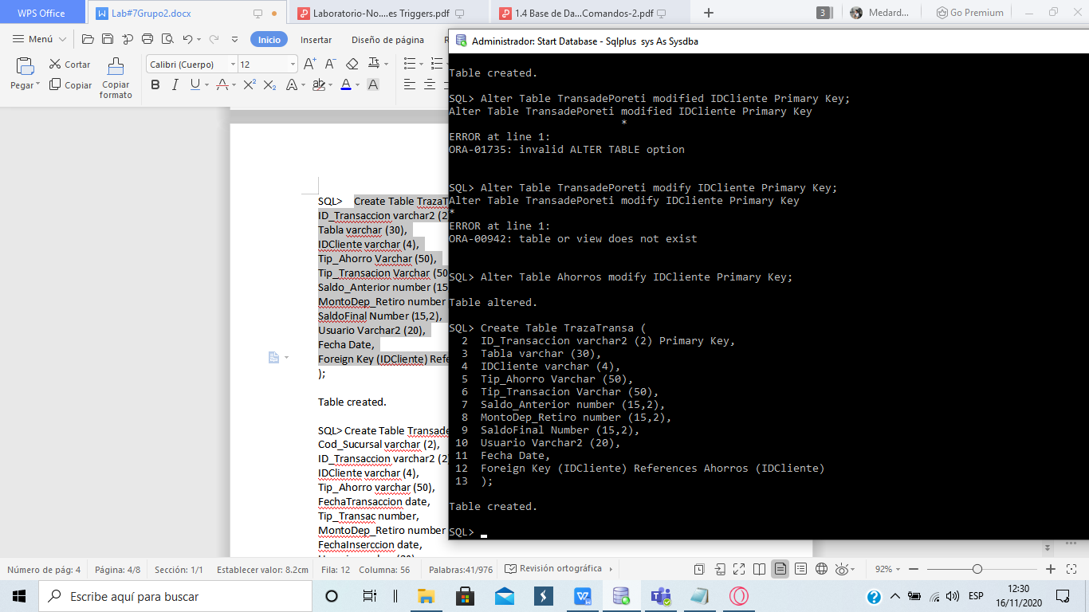

Trigger 1

Create or Repace Trigger UpdateTrazaTransa (

After INSERT OR UPDATE ON Prestamo

Declare c_Prestamo IS

Select * From Prestamo;

Begin

Update TrazaTransa

Set tip_Transacion = Tip_Transacion,

MontoDep_Retiro = MontoDep_Retiro,

Where IDCliente = ID_Cliente;

End UpdateTrazaTransa;

Trigger 2

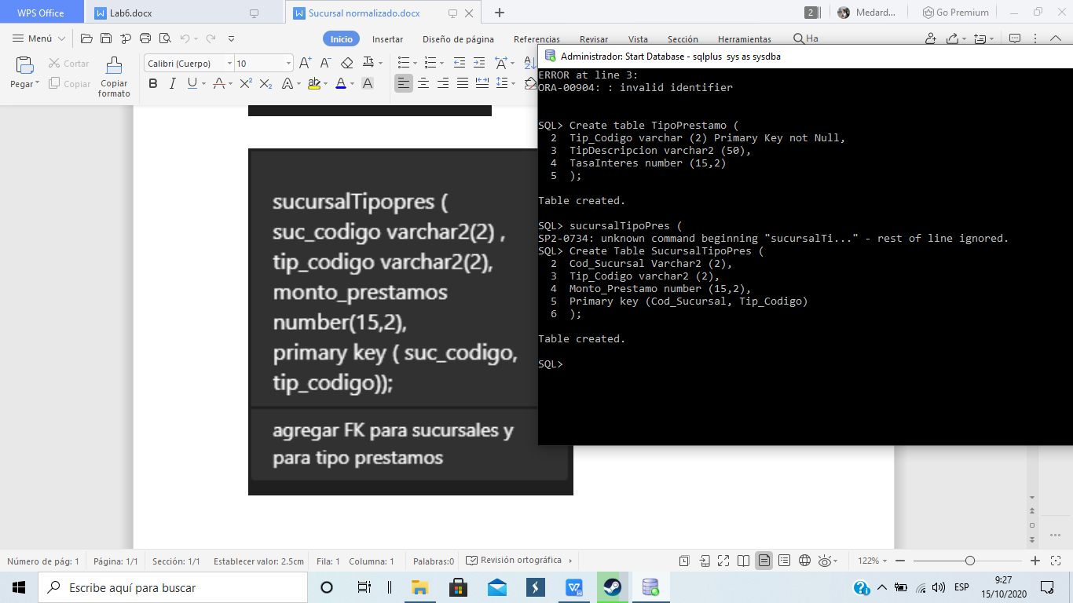

Create or Repace Trigger InsertMonto (

After INSERT ON Prestamo

Declare c_PRestamo IS

Select MontoDep_Retiro

From Prestamo;

Begin

UPDATE SucursalTipoPres

Set Monto_Prestamo = MontoDep_Retiro,

Cod_Sucursal = Cod_Sucursal,

Where Tip_Codigo = ID_Transaccion;

END InsertMonto